## COSC344 Assignment 2

Team: 8

Leader: Ryan

Members:

Ryan Cole - 7038962

Brodie Bosecke - 5471718

Sean Moir - 8475230

Tiaan Brunt- 6603268

**Revised ER diagram**

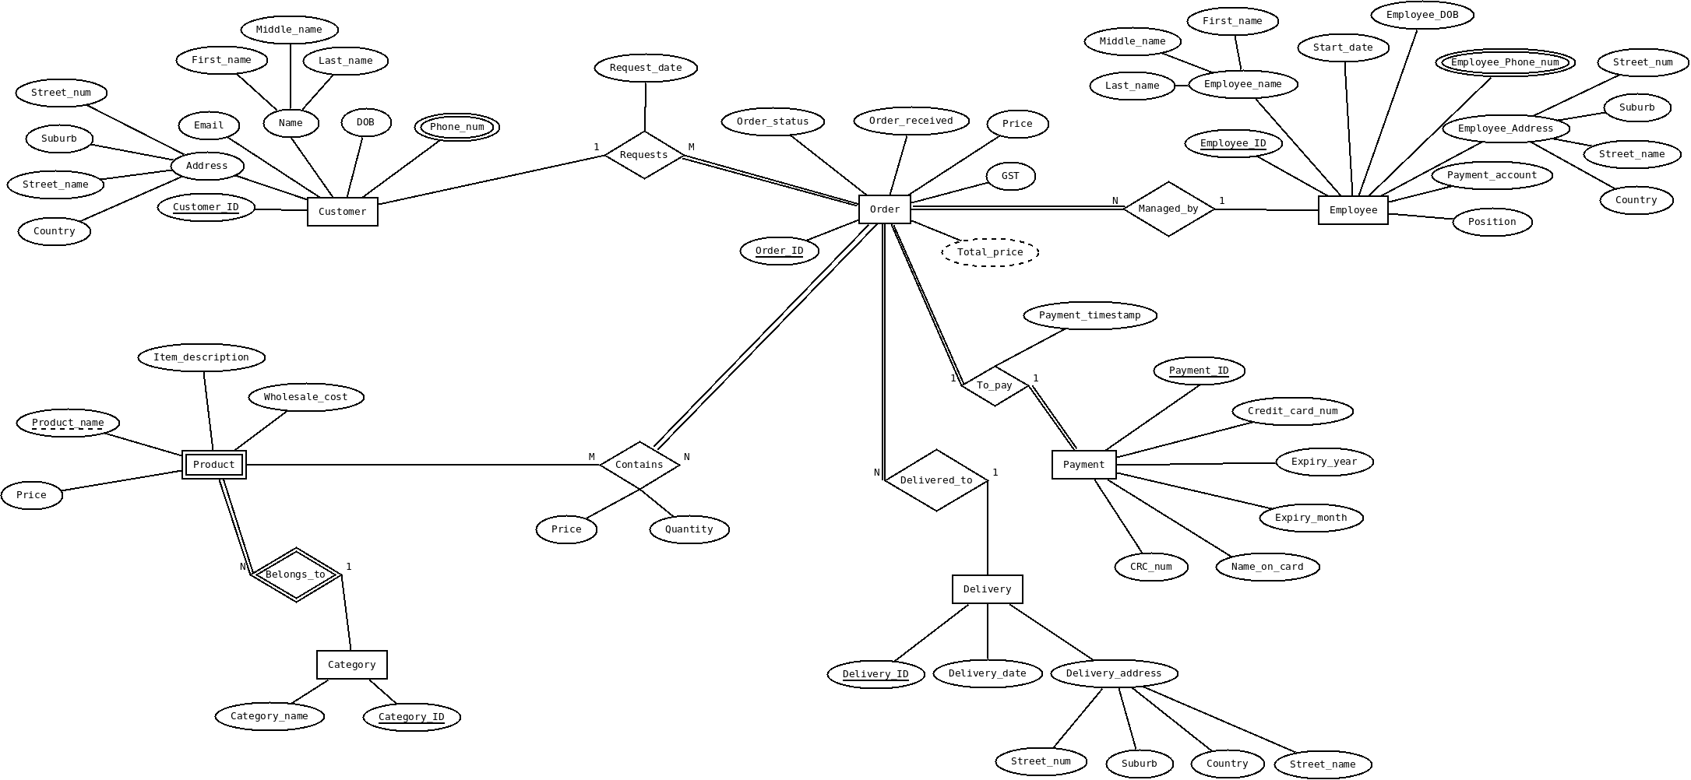

Based on the feedback we received we changed quite a few aspects of our diagram. We removed the order_lines weak entity because it did not accurately represent the relationship of products in an order. Based on the feedback we made the products entity the weak entity, we changed the products identification from product_ID to product_name, and created the relationship orders ‘contains’ products. We also changed the relationship type to M:N because a product can be part of many orders and an order can have many products. Another change we made was to change our delivery address to a composite attribute because we already had the customer address and employee address as a composite values, and wanted to have a uniform format for the addresses. The relationship between product and category was changed to a weak relationship.

**Relational Schema**

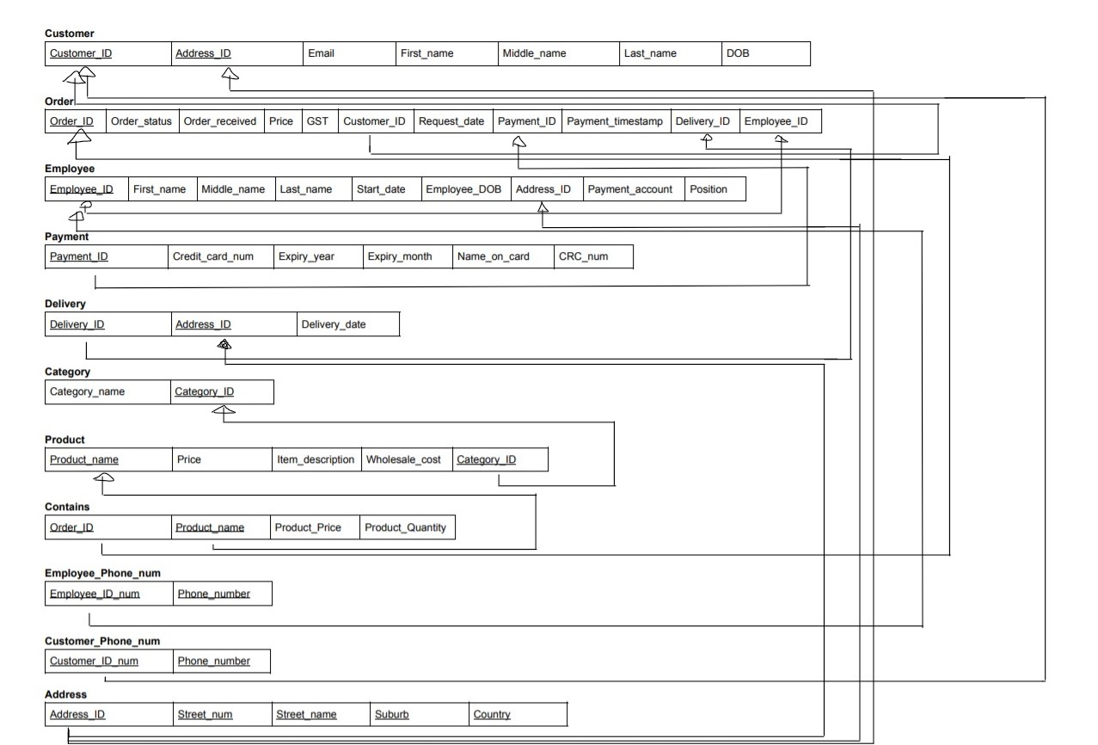

**Normalization**

1NF: Our relation schema is at 1NF because all the attributes of each relation are atomic, the multivalued attributes (employ_phone_num and customer_phone_num) were removed and put into their own relation. The composite attributes were also removed and put into their own relation (Address), the composite attributes were, customer address, delivery address and employee address.

2NF: Our relations meet the requirements for 2NF because all the attributes in each relation only depend on a single primary key. Our relation was already at 2NF without any editing.

3MF: We meet the requirements for 3NF as there are no transitive dependencies thus there are no non-prime attributes that depend on non primary key attributes

BCNF: We meet the requirements for BCNF as there are no dependencies where a super key (primary key) relies on a non-prime attribute in any of the tables.

**load.sql**

DROP TABLE employee_phone_num;

DROP TABLE customer_phone_num;

DROP TABLE contains;

DROP TABLE orders;

DROP TABLE products;

DROP TABLE categorys;

DROP TABLE payment;

DROP TABLE delivery;

DROP TABLE employees;

DROP TABLE customer;

DROP TABLE address;

CREATE TABLE address

(address_ID INT PRIMARY KEY,

street_num VARCHAR(30) NOT NULL,

street_name VARCHAR(30) NOT NULL,

suburb VARCHAR(30) NOT NULL,

country VARCHAR(30) NOT NULL);

INSERT INTO address(address_ID, street_num, street_name, suburb, country)

VALUES(34, '660', 'castle', 'north dunedin', 'new zealand');

INSERT INTO address(address_ID, street_num, street_name, suburb, country)

VALUES(29, '616', 'castle', 'north dunedin', 'new zealand');

INSERT INTO address(address_ID, street_num, street_name, suburb, country)

VALUES(68, '59', 'union', 'north dunedin', 'new zealand');

COMMIT;

CREATE TABLE customer

(customer_ID INT PRIMARY KEY,

address_ID INT REFERENCES address(address_ID),

fname VARCHAR(25) NOT NULL,

mname VARCHAR(25),

lname VARCHAR(25) NOT NULL,

dob DATE NOT NULL,

email VARCHAR(25) NOT NULL

);

INSERT INTO customer(customer_ID, address_ID, fname, mname, lname, dob, email)

VALUES(582, 34, 'john', 'william', 'smith', to_date('04/01/2001', 'DD/MM/YYYY'), 'john@email.com');

INSERT INTO customer(customer_ID, address_ID, fname, mname, lname, dob, email)

VALUES(684, 29, 'henry', 'alan', 'robb', to_date('08/12/1995', 'DD/MM/YYYY'), 'henry@email.com');

INSERT INTO customer(customer_ID, address_ID, fname, mname, lname, dob, email)

VALUES(194, 68, 'sarah', 'georgia', 'cole', to_date('31/03/1987', 'DD/MM/YYYY'), 'georgia@email.com');

COMMIT;

CREATE TABLE delivery

(delivery_ID INT PRIMARY KEY,

delivery_date DATE NOT NULL,

address_ID INT REFERENCES address(address_ID));

INSERT INTO delivery(delivery_ID, delivery_date, address_ID)

VALUES(98, to_date('31/10/2020', 'DD/MM/YYYY'), 34);

INSERT INTO delivery(delivery_ID, delivery_date, address_ID)

VALUES(87, to_date('27/11/2020', 'DD/MM/YYYY'), 29);

INSERT INTO delivery(delivery_ID, delivery_date, address_ID)

VALUES(13, to_date('4/10/2020', 'DD/MM/YYYY'), 68);

COMMIT;

CREATE TABLE categorys

(category_ID INT PRIMARY KEY,

category_name VARCHAR(15) NOT NULL);

INSERT INTO categorys(category_ID, category_name)

VALUES(5, 'hoodies');

INSERT INTO categorys(category_ID, category_name)

VALUES(8, 'pants');

INSERT INTO categorys(category_ID, category_name)

VALUES(2, 'shorts');

COMMIT;

CREATE TABLE products

(product_name VARCHAR(25) PRIMARY KEY,

category_ID INT REFERENCES categorys(category_ID),

item_description VARCHAR(20),

price NUMERIC(15,2) NOT NULL,

wholesale_cost NUMERIC(15,2) NOT NULL);

INSERT INTO products(product_name, category_ID, item_description, price, wholesale_cost)

VALUES('cool hoodie', 5, 'black hoodie', 24.9, 12.5);

INSERT INTO products(product_name, category_ID, item_description, price, wholesale_cost)

VALUES('branded pants', 8, 'warm pants', 19.9, 9.7);

INSERT INTO products(product_name, category_ID, item_description, price, wholesale_cost)

VALUES('soccer shorts', 2, 'sports shorts', 22.9, 11.3);

COMMIT;

CREATE TABLE payment

(payment_ID INT PRIMARY KEY,

credit_card_num INT NOT NULL,

name_on_card VARCHAR(25) NOT NULL,

expiry_month INT NOT NULL,

expiry_year INT NOT NULL,

crc_num INT NOT NULL);

INSERT INTO payment(payment_ID, credit_card_num, name_on_card, expiry_month, expiry_year, crc_num)

VALUES(32485, 1111222233334444, 'J W Smith', 11, 24, 000);

INSERT INTO payment(payment_ID, credit_card_num, name_on_card, expiry_month, expiry_year, crc_num)

VALUES(23987, 1111222233334444, 'H A Robb', 02, 23, 000);

INSERT INTO payment(payment_ID, credit_card_num, name_on_card, expiry_month, expiry_year, crc_num)

VALUES(89133, 1111222233334444, 'S A Cole', 07, 23, 000);

COMMIT;

CREATE TABLE employees

(employee_ID INT PRIMARY KEY,

employee_fname VARCHAR(30) NOT NULL,

employee_mname VARCHAR(30),

employee_lname VARCHAR(30) NOT NULL,

employee_DOB DATE NOT NULL,

start_date DATE NOT NULL,

payment_account VARCHAR(20) NOT NULL,

address_ID INT REFERENCES address(address_ID),

employee_position VARCHAR(15) NOT NULL);

INSERT INTO employees(employee_ID, employee_fname, employee_mname, employee_lname, employee_DOB, start_date, payment_account, address_ID, employee_position)

VALUES(98405, 'brodie', 'scott', 'bosceke', to_date('27/11/1983', 'DD/MM/YYYY'), to_date('21/10/2018', 'DD/MM/YYYY'), '0348570948356-00', 34, 'manager');

COMMIT;

CREATE TABLE orders

(order_ID INT Primary KEY,

order_Status VARCHAR(20) NOT NULL,

order_Received DATE NOT NULL,

price NUMERIC(15,2) NOT NULL,

GST NUMERIC(15,2) NOT NULL,

customer_ID INT REFERENCES customer(customer_ID),

request_date DATE NOT NULL,

payment_ID INT REFERENCES payment(payment_ID),

payment_timestamp TIMESTAMP DEFAULT CURRENT_TIMESTAMP,

delivery_ID INT REFERENCES delivery(delivery_ID),

employee_ID INT REFERENCES employees(employee_ID)

);

INSERT INTO orders(order_ID, order_status, order_Received, price, GST, customer_ID, request_date, payment_ID, payment_timestamp, delivery_ID, employee_ID)

VALUES(02835, 'packing', to_date('27/07/2020', 'DD/MM/YYYY'), 49.9, 11.4, 582, to_date('26/07/2020', 'DD/MM/YYYY'), 32485, CURRENT_TIMESTAMP, 98, 98405);

COMMIT;

CREATE TABLE contains

(order_ID INT REFERENCES orders,

product_name VARCHAR(25) REFERENCES products(product_name),

product_price INT NOT NULL,

product_quantity INT NOT NULL);

INSERT INTO contains(order_ID, product_name, product_price, product_quantity)

VALUES(02835, 'soccer shorts', 22.9, 2);

COMMIT;

CREATE TABLE employee_phone_num

(employee_ID INT REFERENCES employees(employee_ID),

phone_number INT NOT NULL);

INSERT INTO employee_phone_num(employee_ID, phone_number)

VALUES(98405, 02405423940);

INSERT INTO employee_phone_num(employee_ID, phone_number)

VALUES(98405, 06105433650);

INSERT INTO employee_phone_num(employee_ID, phone_number)

VALUES(98405, 02430542365);

COMMIT

CREATE TABLE customer_phone_num

(customer_ID INT REFERENCES customer(customer_ID),

phone_number INT NOT NULL);

INSERT INTO customer_phone_num(customer_ID, phone_number)

VALUES(582, 02105323950);

INSERT INTO customer_phone_num(customer_ID, phone_number)

VALUES(684, 03105423650);

INSERT INTO customer_phone_num(customer_ID, phone_number)

VALUES(194, 0230542355);

COMMIT;

**Teamwork Summary**

All members of the group contributed to each section in this assignment. We each mapped an entity type and relation type separately before combining our work together into a single relation schema. The normalization was discussed by all group members so we all understood the process before each member checked to see if their relation tables were normalised or not. We then had another meeting to discuss what we achieved and put our results into a shared document. The load.sql file was created throughout the assignment with each member contributing individually. Prior to submission, each member proof-read to make sure they were happy before submitting the final copy of the assignment.